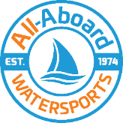
Visually Impaired Rowing Open Day

Name: …………….………………………………………..………………
Tel / Mobile: ………………………………………………………………
E-mail : ……………………………………………………….…………..…
Emergency Contact for Open Day (Name & Number) :
………………………………………………………………………………….

Photo Consent: Photos and videos will be used for promotional reasons by All-Aboard, Sight Support & Bristol Gig Club.

Communication Consent: You are happy for All-Aboard to e-mail you or contact you about future projects or watersport opportunities.

Progression from Open Day: If you enjoy your rowing experience, would you like to be contacted about attending:
Learn to Row Courses (6 – week course)
Informal rowing sessions with an instructor
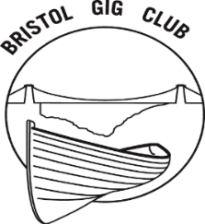
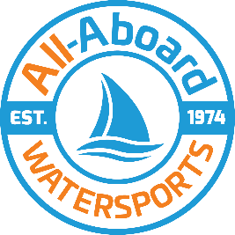

Equality Monitoring Form

Gender (Please tick the gender you identify as)
☐ Male ☐ Female ☐ Non-binary
☐Intersex

Age
☐16 - 24 ☐ 25 - 34 ☐ 35 - 44 ☐ 45 – 54
☐55 – 64 ☐ 65 - 74 ☐ 75 – 84 ☐ 85 +

Ethnicity
☐White ☐Black ☐Asian ☐Mixed race
☐Other

Disability (Tick appropriate)
☐Visual ☐Physical ☐Hearing
☐Learning ☐Social ☐ Mental Health

