NEWSLETTER – February 2017

With the days gradually growing longer and weather becoming milder, All-Aboard has been getting ready for the start of the season. Building work upstairs to insert an office and storage cupboard, along with a good spruce-up of the centre with the help of Occupational Therapy students from UWE has certainly made the centre look the part in preparation for this year’s season.
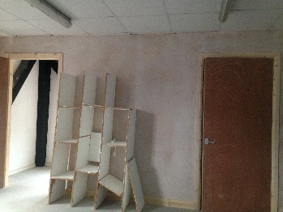
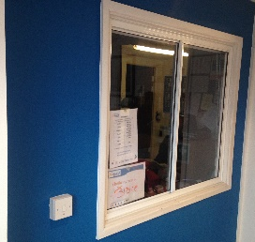
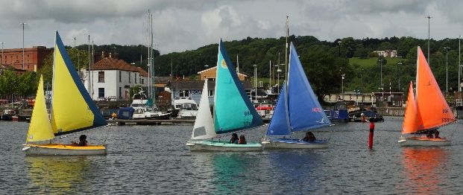

A changeover of staff - Finance Officer

It is with regret to announce that our Finance Officer, Tracie Roberts will be leaving at the end of this month. We wish Tracie all the best in the future.

Sarah Harding will be stepping into the role in March. Sarah has is a keen sailor herself, regularly sailing at Chew Valley Sailing Club. Sarah has become familiar with the work we do, during her involvement in All-Aboard over the last few months – so she will be a great addition. Sarah will be based in the office on Tuesdays and Thursdays.

ATTENTION FOR ALL VOLUNTEERS – New Sign-in Procedure
We now have a registration book in the office for our volunteers to sign in whenever they come for a session.
This allows us to know who is on the premises as well as giving us a central record of volunteer hours. Please could you ensure that you sign in whenever you come and write which group or activity you are volunteering for. This system will run alongside your personal volunteer logbooks, which are your record of the hours you put in and count towards your training points.
Thank you in anticipation for your support in this.

Metro Bus Update

Please see the last two pages for the Metro Bus Newsletter, which states updates and opening roads.
An SEN School’s Experience of All-Aboard

Schools and colleges have continued to come and enjoy the calming influence of the harbour throughout February. A regular attender, Kingsweston School, had this to say about their time at All-Aboard:

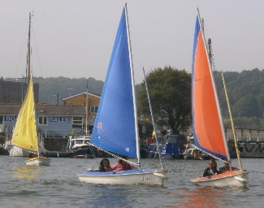
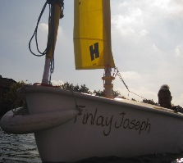
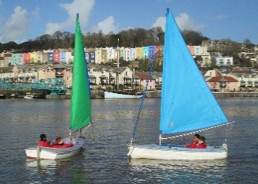
At Kingsweston School we have been working closely with All-Aboard Watersports for four years. They have given our pupils – all of whom have an Autistic Spectrum Condition (many have additional needs as well) – the opportunity to experience something that would have seemed completely inaccessible to them, and challenge themselves in doing so. Some pupils have enjoyed the experience of riding in a boat for the first time, overcoming a fear of being on the water – a number of pupils of various ages who were initially apprehensive about going on Aiming High have all found themselves in sailing dinghy’s within 6 weeks. Others have taken the opportunity to take it further and successfully compete in rowing and sailing against other schools – something that they would not have believed themselves capable of doing at the outset of the sessions. A number of our pupils now access the club out of school as a result. All of our pupils have learnt new skills – be they specific skills relating to sailing or more general skills around following instructions and staying safe around water, and every child we have taken over the years has fully enjoyed the experience and expressed a willingness to return. Each of the activities that we access (sailing, group kayaking and riding on Aiming High) offer something specific and worthwhile to our students – the chance to work as a team or be in complete independent control of a boat. This sense of empowerment, responsibility and independence runs to the very core of what we try to do for our students as a school.

Sailability Conference
By Gill Hannan

With the new Sailability Lead, Joff McGill, as host, this year’s conference had a very positive, can-do atmosphere. Building on the work Blaire & Hannah, supported by our Trustee Board, did last year to lobby for disabled sailors to be eligible to become full RYA Sailing Instructors ; Joff opened the Conference with a commitment to increasing the number of disabled instructors ( currently only one!) and level 2 racing coaches. The conference was a chance to catch up with other groups around the country and discuss best practice, with afternoon workshops which have given us new ideas for supporting our volunteers and developing our activities. Watch out, Gill has come back recharged and on a mission!
Red Nose Day Challenge

Our Seasonal Instructor, Tilly Parry, and CEO, Nicola are organising a 24hour Red Nose Day event on the 11th and 12th March. The plan is to row on the ergos over the evening on the 11th starting at 6pm. We then want to run sailing, kayaking and rowing sessions during the day taking us up to 6pm on the 12th.
We want to track the distances of all the sports and total them all together.
We are looking for instructors to help run this event all for charity.
If you could let the office know if you are available that would be great. Any help over the days would be great; we want to have all of the sports covered with qualified instructors.

A Potted History of All-Aboard

Following our segment of the history of Bristol Floating Harbour, we thought you may be interested in the history of All-Aboard;
Our organisation has not always been known as All-Aboard but has developed over many years.
When Chew Valley was flooded for a reservoir Bristol Youth and Schools Sailing Association was formed in 1956 and given the right for Bristol Schools to sail with mainly secondary age children, at Chew Valley Lake.
This organisation developed into Bristol Schools Sailing Association in 1965. Two primary teachers Bob Searle and Gerry Carey, started sailing in the docks in late 1960’s.
In 1974 the Avon Schools Sailing Association was formed which finally in 1996 became The West of England Sailing Association (WESSA).
The Bristol Sailing School was taken over by the WESSA committee to provide commercial courses and a much needed source of income to keep the organisation going as finance from Local Education grants dried up. A lease was taken out on part of the Dutch Barn at Baltic Wharf which over the years has been developed into the present facility with help from Lottery Grants and the Olympic Heritage Fund.
With the demise of teachers bringing pupils sailing and with the teachers remaining being of ‘a certain age’ there was a feeling that organisation needed to change to have a lasting legacy. It was also felt that the organisation should be more inclusive and offer more in the realm of water sport for the population of Bristol.
So in 2012 WESSA was wound up and the resources transferred to the new organisation All-Aboard Watersports .
A feature of All-Aboard has been the integration of Sailability into the new structure making it a fully inclusive organisation. This enables anyone from any background, culture, need or financial circumstance to participate in any course or activity. This structure is unique, which no other Royal Yachting Association Centre has adopted. AA continues to progress with the development of disability watersports in rowing and canoeing . Thanks to the CSAF funding , we now welcome a large and vibrant number of 55+ year olds, many of whom are extending their involvement to become reliable volunteers, learning new skills and supporting others to participate. In 2014 All-Aboard became the tenth centre of excellence for Sailability in the UK, This year, 2017 we are again looking at new sports to include, the development continues.
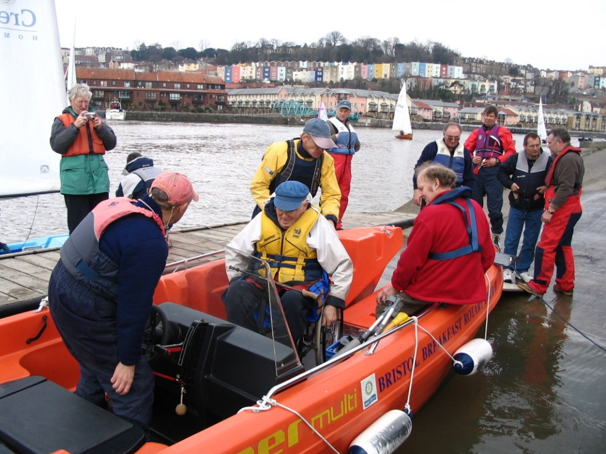
Through various grants and generous donations and sponsorship, the boat yard has gradually filled with boats and vast changes to the interior of All-Aboard had occurred by 2012. This included fitting a ceiling and second floor, putting in a lift, moving the galley from downstairs to upstairs, creating an accessible front entrance, creating a shower room and changing rooms. Most of the work was carried out by dedicated volunteers under the guidance of professionals. Along with the sporting fever of the London 2012 Games, which increased the numbers coming through our doors, and the thousands of volunteer hours and hard work by many, this is what made All-Aboard what it is today. A tribute to all vision of the founding instructors and all who break sweat over All-Aboard!

A Photo of all the original instructors - Jim Bull, Mike Fotherby, Alan, David Williams, Charles Richardson, Brian Howell, Mike Malcher, Geof Lane and Steve Evans.

UPCOMING EVENTS

Canoe Instructor Course at All-Aboard, 1st, 2nd 8th, 9th April

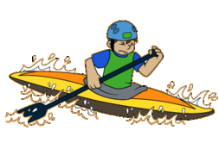
Clevedon Canoe Club are running a Level Coaching course on the 1st, 2nd, 8th,9th April at All-Aboard in Bristol Docks for a cost of £210, plus a £45 registration fee (paid directly to British Canoeing.

If you would like to make a booking please go to :

www.clevedoncanoeclub.org.uk/course-booking

There are 9 places left, so sign up quick!

Autism Workshops at Bristol Harbouside

The Curly Haired Project are providing talks on the different aspects of Autism. Please note that these talks are not provided at or by All-Aboard thus you would be attending independent of our centre. See below for details.

ASD & Sensory Processing – Mon 10th Apr, 10am-12.30pm
The Essential Guide to ASD – Mon 19th June, 10am-12.30pm
ASD &Anxiety - Mon 3rd Jul, 10am-12.30pm

Location: The Pavilion, No1 Hannover Quay, Harbourside, Bristol, BS1 5JE

Book online at: www.thegirlwiththecurlyhair.co.uk/events

